**Tugas2**

**(Membuat Biodata Sederhana)**



**Disusun Oleh :**

Arief Nauvan Ramadha

Junior Web Developer A

**PELATIHAN VSGA**

**JUNIOR WEB DEVELOPER**

**DIGITAL TALENT SCHOLARSHIP**

**2021**

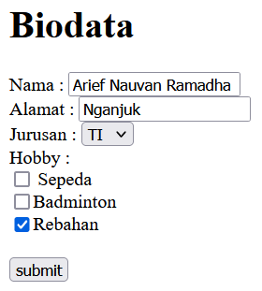

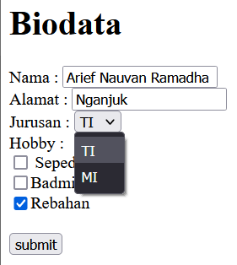

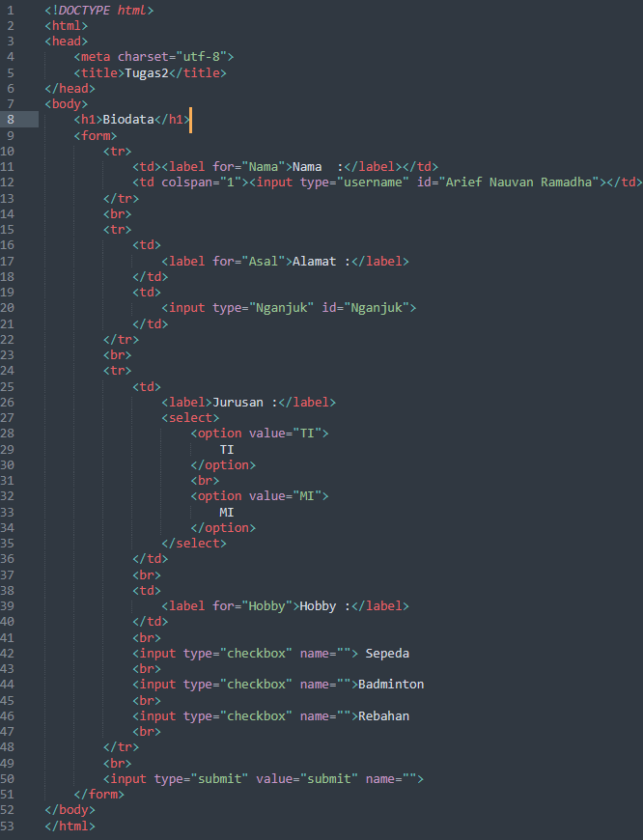

|  |
| --- |
| **<!DOCTYPE html>**  **<html>**  **<head>**  **<meta charset="utf-8">**  **<title>Tugas2</title>**  **</head>**  **<body>**  **<h1>Biodata</h1>**  **<form>**  **<tr>**  **<td><label for="Nama">Nama :</label></td>**  **<td colspan="1"><input type="username" id="Arief Nauvan Ramadha"></td>**  **</tr>**  **<br>**  **<tr>**  **<td>**  **<label for="Asal">Alamat :</label>**  **</td>**  **<td>**  **<input type="Nganjuk" id="Nganjuk">**  **</td>**  **</tr>**  **<br>**  **<tr>**  **<td>**  **<label>Jurusan :</label>**  **<select>**  **<option value="TI">**  **TI**  **</option>**  **<br>**  **<option value="MI">**  **MI**  **</option>**  **</select>**  **</td>**  **<br>**  **<td>**  **<label for="Hobby">Hobby :</label>**  **</td>**  **<br>**  **<input type="checkbox" name=""> Sepeda**  **<br>**  **<input type="checkbox" name="">Badminton**  **<br>**  **<input type="checkbox" name="">Rebahan**  **<br>**  **</tr>**  **<br>**  **<input type="submit" value="submit" name="">**  **</form>**  **</body>**  **</html>** |